**Topic: Bank Client Analysis**

**Team: Turtle**

*Dataset*: Bank Marketing Dataset

*Question that we are interested in finding*:

* What factors influence people of subscribing a term deposit?

(Term Deposit is a fixed-term deposit of money held by a bank with short maturities from one month to a few years)

*Tools and Skills Used*:

Tools: R, Python

Skills: data cleaning, munging, visualization with ggplot and matplotlib

*Methodology*:

1. Decided to find out what factors influence people of subscribing a term deposit
2. Started cleaning and munging
3. Ran a random forest model
4. Visualized important variables

*Visualization Result*:

1. Relationship between age and subscription of term deposit:

We can see that age between 25 to 60 has a low subscription of term deposit compare to those below 25 and above 60.

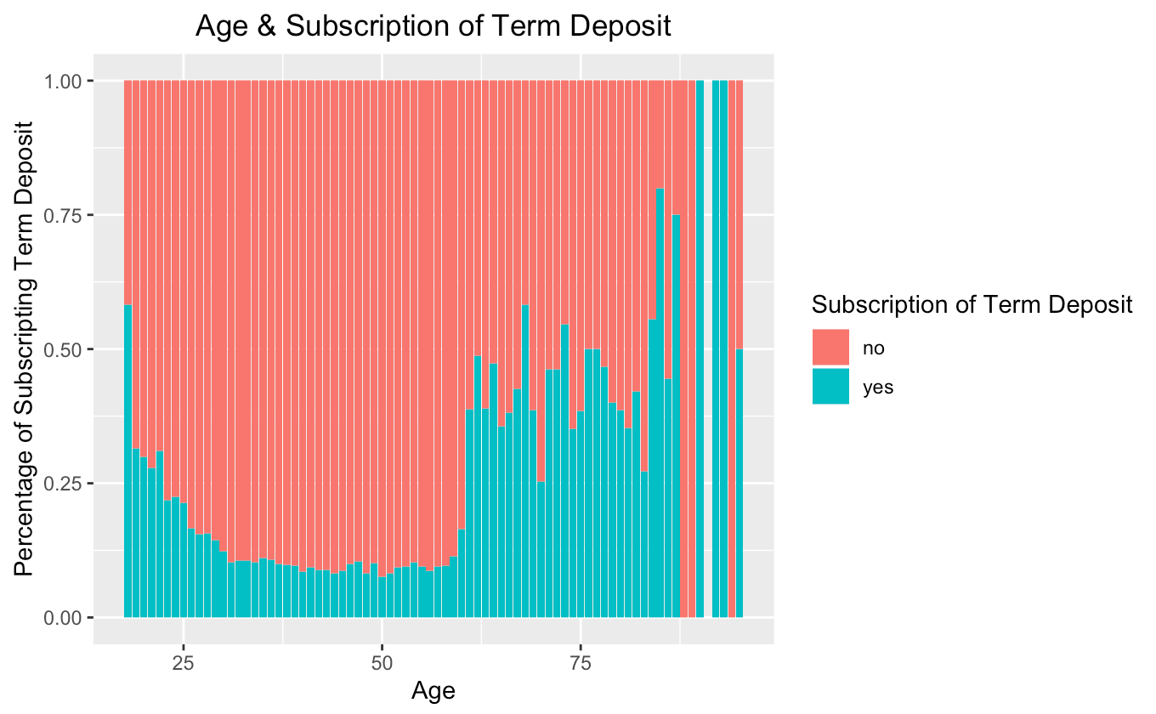

1. Relationship between Age and bank Loan :

This explains the above graph which age between 25 to 60 has a low subscription of term deposit because they have housing loan and bank loan. This means that the customer has a financial compromises to pay back its house loan and bank loan. Therefore, there is no cash for he or she to subscribe to a term deposit account. People over 60 are mostly retired people who tend to have more term deposits in order to gain interest payments.

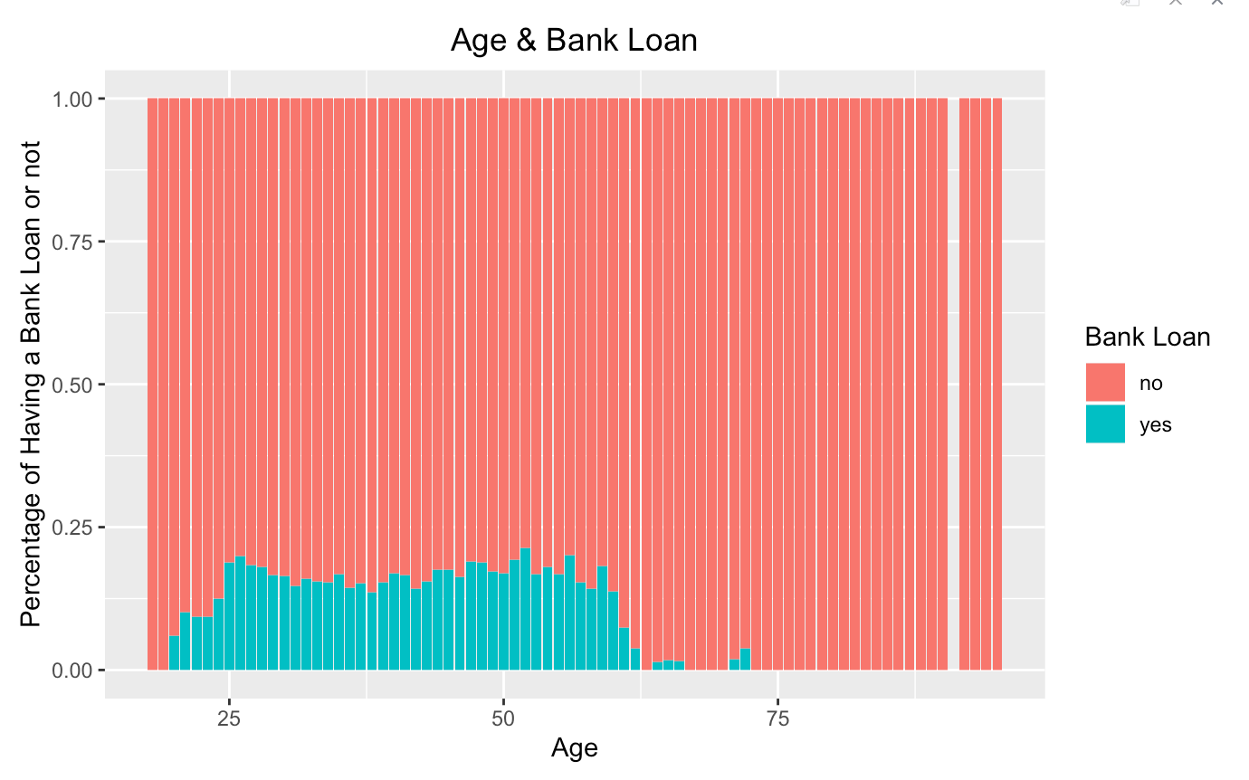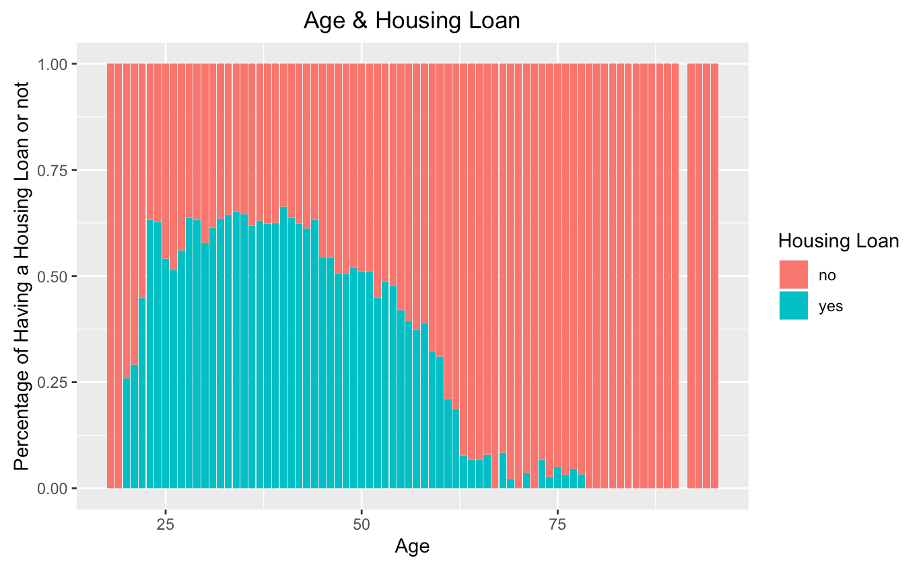

1. Relationship between duration and Term Deposit:

This boxplot shows that the average duration of making customer subscribe is about 500 seconds which is approximately 8 minutes. The shorter the duration, people are less likely to subscribe the term deposit.

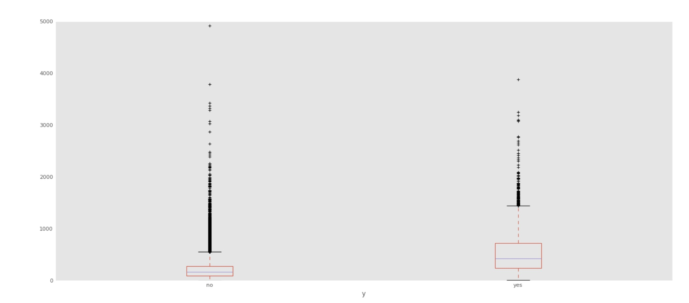

1. Term Deposit grouped by Age and Campaign:

The size of the bubble indicated how many times a customer receives calls. The graph

shows that the more calls people receive, people age 20-60 are more likely to subscribe

to the term deposit.

1. Relationship between month and subscription of term deposit:

The graph showed that in March, September, October, and December, people are more likely to subscribe to term deposit.

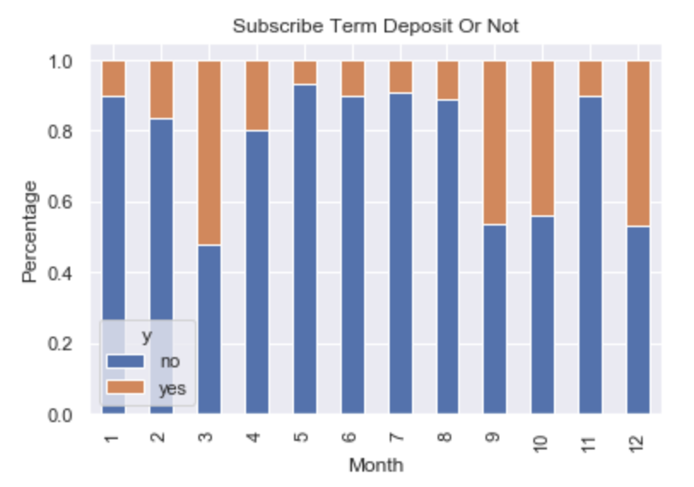

1. People who said yes to term deposit:

Throughout the people who subscribe to term deposit, most people are in age 35 with receiving calls of 250 seconds.

*Suggestions for the Next Marketing Campaign:*

* Age: The bank should target young people who is **under 25** and people **older than 60**.
* Month of Marketing Activity: Since **March, September, October and December** has a higher acceptance rate, the bank should focus on those months instead of May which has the highest marketing activity.
* Duration: Duration has positive effect on making people to subscribe the term deposit. This is because the longer the conversations on the phone, the higher interest the customer will show to the term deposit. Thinking of ways to make the call interesting is an important part for the next marking campaign.

It is possible that the next marketing campaign will be more effective and more successful than the current one if the bank combines these strategies.